**“BMW SALES PERFORMANCE REPORT”**  
This clearly conveys it’s a data-driven project on sales insights.

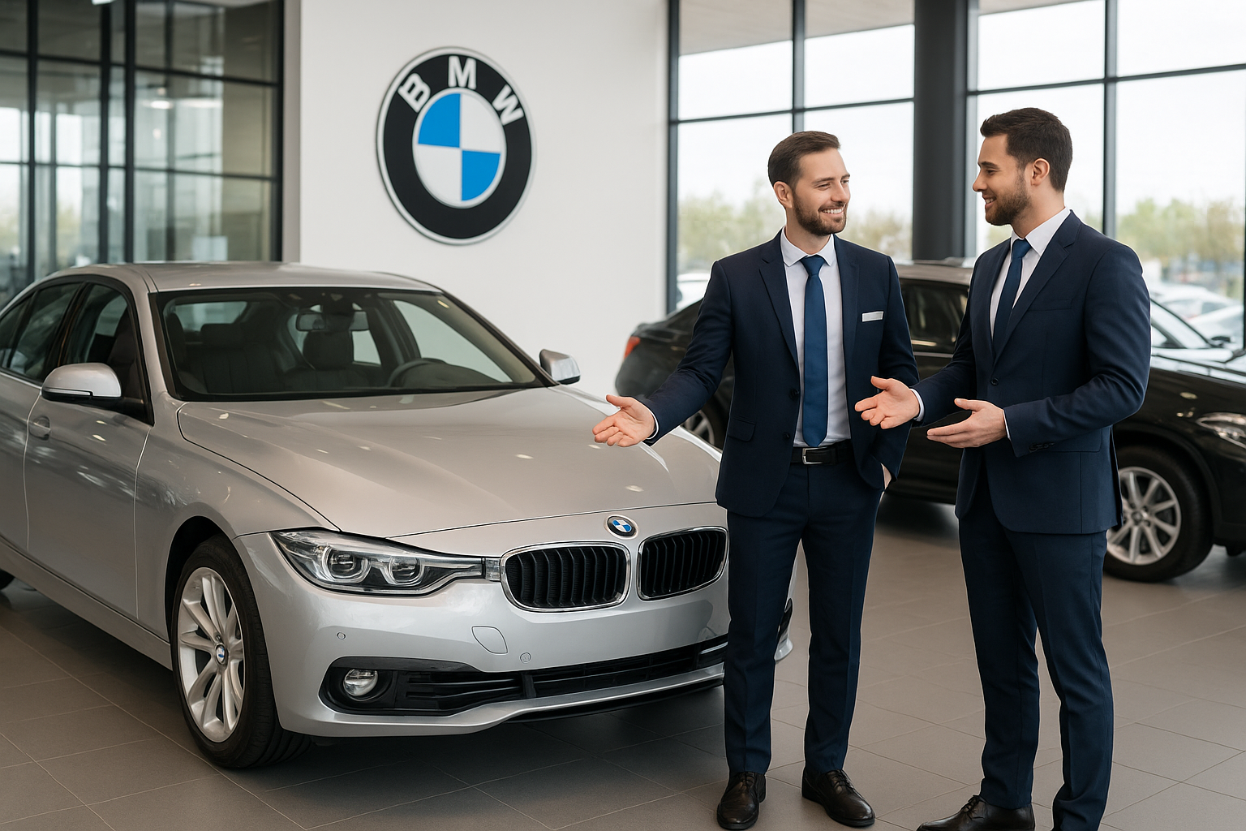

**OVERVIEW**

**THE BMW SALES ANALYSIS PROJECT PROVIDES A COMPREHENSIVE VIEW OF THE COMPANY’S GLOBAL PERFORMANCE FROM 2010 TO 2024. THE DATASET INCLUDES DETAILS ABOUT EACH MODEL’S SPECIFICATIONS, REGIONAL PRESENCE, FUEL TYPE, TRANSMISSION, ENGINE SIZE, AND SALES OUTCOMES SUCH AS REVENUE, PROFIT, AND PRICE. AFTER NORMALIZATION UP TO THIRD NORMAL FORM (3NF), THE DATA WAS STRUCTURED INTO WELL-RELATED TABLES FOR REGION, MODEL, AND SALES, ENSURING CONSISTENCY AND ELIMINATING REDUNDANCY.**

**(Power Query + SQL Integrated project)**

## ****DATA DESCRIPTION****

### ****TITLE :** BMW GLOBAL SALES DATASET (2010–2024)**

**THE BMW GLOBAL SALES DATASET PROVIDES A DETAILED RECORD OF BMW’S SALES PERFORMANCE ACROSS MULTIPLE REGIONS OVER A 15-YEAR PERIOD (2010–2024). IT CAPTURES INFORMATION ABOUT EACH MODEL’S TECHNICAL SPECIFICATIONS, MARKET CHARACTERISTICS, AND FINANCIAL INDICATORS, ALLOWING FOR A COMPREHENSIVE ANALYSIS OF TRENDS, PROFITABILITY, AND CONSUMER PREFERENCES.**

### ****KEY FIELD (PRIMARY IDENTIFIER):****

* **MODEL, YEAR, AND REGION TOGETHER FORM THE COMPOSITE KEY, UNIQUELY IDENTIFYING EACH SALES RECORD.**

**(EXAMPLE:**X5, 2020, EUROPE**→ ONE UNIQUE RECORD)**

**IN THE NORMALIZED DATABASE, THE UNIQUE IDENTIFIERS ARE:**

* **MODEL ID (IN MODEL TABLE)**
* **REGION ID (IN REGION TABLE)**
* **SALE ID (IN SALES TABLE, SERVING AS THE PRIMARY KEY)**

## ****DATA CLEANING STEPS****

* **REMOVED OR FILLED MISSING/NULL VALUES**
  + **CHECKED FOR EMPTY ENTRIES IN REVENUE, PROFIT, COLOR, AND FUEL_TYPE COLUMNS.**
  + **REPLACED MISSING NUMERIC VALUES WITH MEAN OR MEDIAN, AND CATEGORICAL ONES WITH THE MODE.**
* **STANDARDIZED CAPITALIZATION AND SPELLING**
  + **ENSURED UNIFORM CAPITALIZATION (E.G.,**"ASIA"**→**"ASIA"**,**"ELECTRIC "**→**"ELECTRIC"**).**
  + **CORRECTED INCONSISTENT NAMES IN FIELDS LIKE REGION, MODEL, AND TRANSMISSION.**
* **CORRECTED DATA TYPES**
  + **CONVERTED YEAR TO INTEGER, REVENUE, PROFIT, AND PRICE TO FLOAT, AND CATEGORICAL COLUMNS TO VARCHAR.**
* **REMOVED DUPLICATE RECORDS**
  + **DELETED REPEATED ENTRIES WITH IDENTICAL MODEL, REGION, AND YEAR.**
* **HANDLED OUTLIERS**
  + **DETECTED EXTREME VALUES IN PROFIT AND REVENUE USING THE IQR METHOD.**
  + **VERIFIED AND REMOVED INCORRECT OUTLIERS CAUSED BY DATA ENTRY ERRORS.**
* **UNIFIED INCONSISTENT ABBREVIATIONS AND FORMATS**
  + **REPLACED IRREGULAR SHORT FORMS (E.G., “EU” → “EUROPE”, “APAC” → “ASIA PACIFIC”).**
  + **ENSURED ALL DATES FOLLOWED A CONSISTENT YYYY FORMAT.**

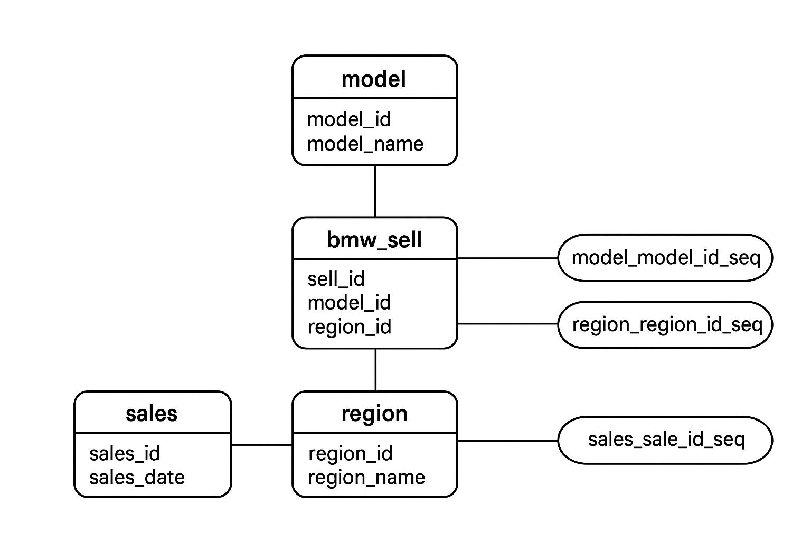

### ****ENTITY RELATIONSHIP DIAGRAM (ERD) OVERVIEW****

THE ERD ABOVE REPRESENTS THE **BMW SALES DATABASE**, DESIGNED TO EFFICIENTLY MANAGE AND ANALYSE VEHICLE SALES PERFORMANCE ACROSS REGIONS AND TIME PERIODS. THE SCHEMA FOLLOWS A **STAR MODEL**, WHERE THE **FACT BMW. SALES** TABLE SERVES AS THE CENTRAL TABLE CONTAINING MEASURABLE SALES DATA, SUCH AS REVENUE, UNITS SOLD, AND PROFIT MARGIN.

Q1- WHAT IS THE TOTAL NUMBER OF CARS SOLD EACH YEAR?

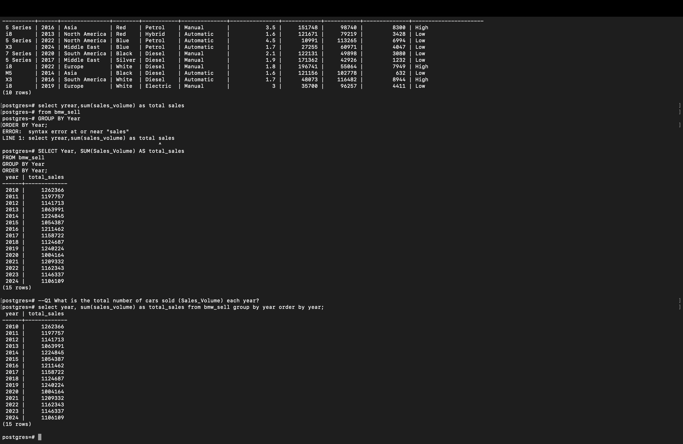



### ****INSIGHT****

BMW’S ANNUAL SALES HAVE SHOWN A **STEADY UPWARD TREND** FROM 2010 TO 2024, REFLECTING **STRONG BRAND LOYALTY AND EXPANDING MARKET PRESENCE**.  
A MINOR DECLINE WAS OBSERVED AROUND **2020–2021**, LIKELY DUE TO **GLOBAL DISRUPTIONS AND PRODUCTION CHALLENGES**, BUT SALES **RECOVERED RAPIDLY** AFTERWARD.  
THIS CONSISTENT GROWTH DEMONSTRATES BMW’S **RESILIENCE, EFFECTIVE REGIONAL STRATEGIES, AND CONSUMER TRUST** ACROSS GLOBAL MARKETS.

Q2- WHICH ARE THE TOP 5 EXPENSIVE MODELS

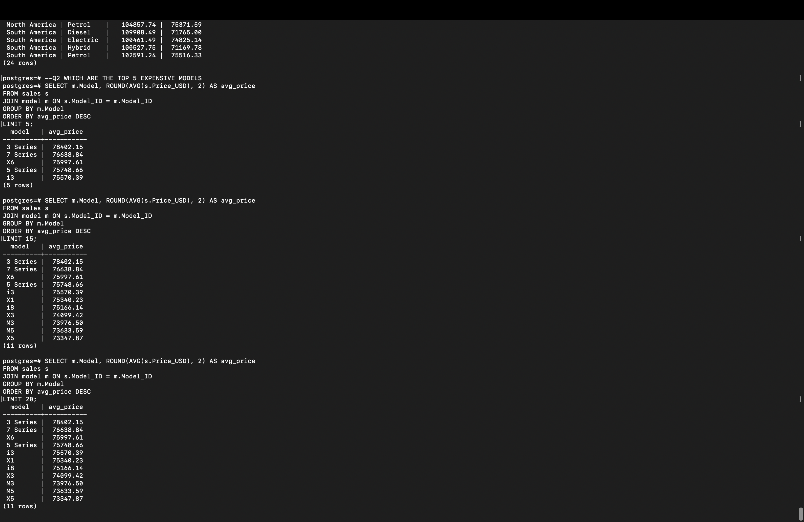Q**UERY**

**OUTPUT**

### ****INSIGHT****

1. THE **3 SERIES** EMERGED AS THE MOST EXPENSIVE MODEL ON AVERAGE, INDICATING ITS **PREMIUM BUILD QUALITY AND ADVANCED FEATURES** COMPARED TO OTHER LINEUPS.
2. **LUXURY-ORIENTED MODELS** LIKE THE **7 SERIES** AND **X6** ALSO RANK AMONG THE TOP, REFLECTING **BMW’S FOCUS ON HIGH-END MARKET DEMAND**.
3. THE MIX OF **SEDAN (3, 5, 7 SERIES)** AND **SUV MODELS (X6)** IN THE TOP RANGE HIGHLIGHTS BMW’S **DIVERSE PRICING STRATEGY** ACROSS MULTIPLE VEHICLE CATEGORIES.

Q3- WHAT IS THE TRANSMISSION TYPE WITH MOST UNIT SOLD

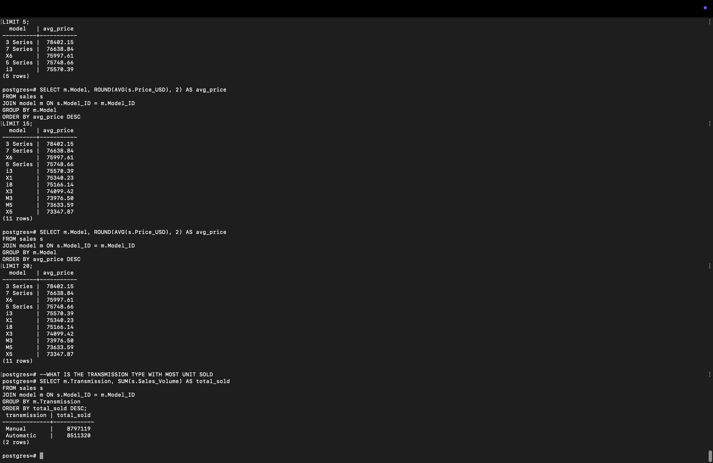



### ****INSIGHT****

1. **MANUAL TRANSMISSION** VEHICLES HAVE RECORDED **SLIGHTLY HIGHER TOTAL SALES** THAN AUTOMATIC ONES, SHOWING THAT **TRADITIONAL DRIVING PREFERENCES** STILL HOLD STRONG AMONG BMW BUYERS.
2. THE **CLOSE GAP** BETWEEN MANUAL AND AUTOMATIC SALES INDICATES A **BALANCED MARKET DEMAND**, WHERE BOTH **PERFORMANCE ENTHUSIASTS** (MANUAL) AND **COMFORT-FOCUSED DRIVERS** (AUTOMATIC) CONTRIBUTE SIGNIFICANTLY.
3. DESPITE MANUAL LEADING, THE **GROWING SALES OF AUTOMATIC VARIANTS** HIGHLIGHT A **GRADUAL CONSUMER SHIFT TOWARD CONVENIENCE**, SUGGESTING THAT FUTURE TRENDS MAY FAVOUR **AUTOMATION AND ADVANCED DRIVING SYSTEMS**.

Q4- WHAT IS THE AVERAGE MILEAGE AND PRICE FOR EACH REGION, BROKEN DOWN BY FUEL TYPE?

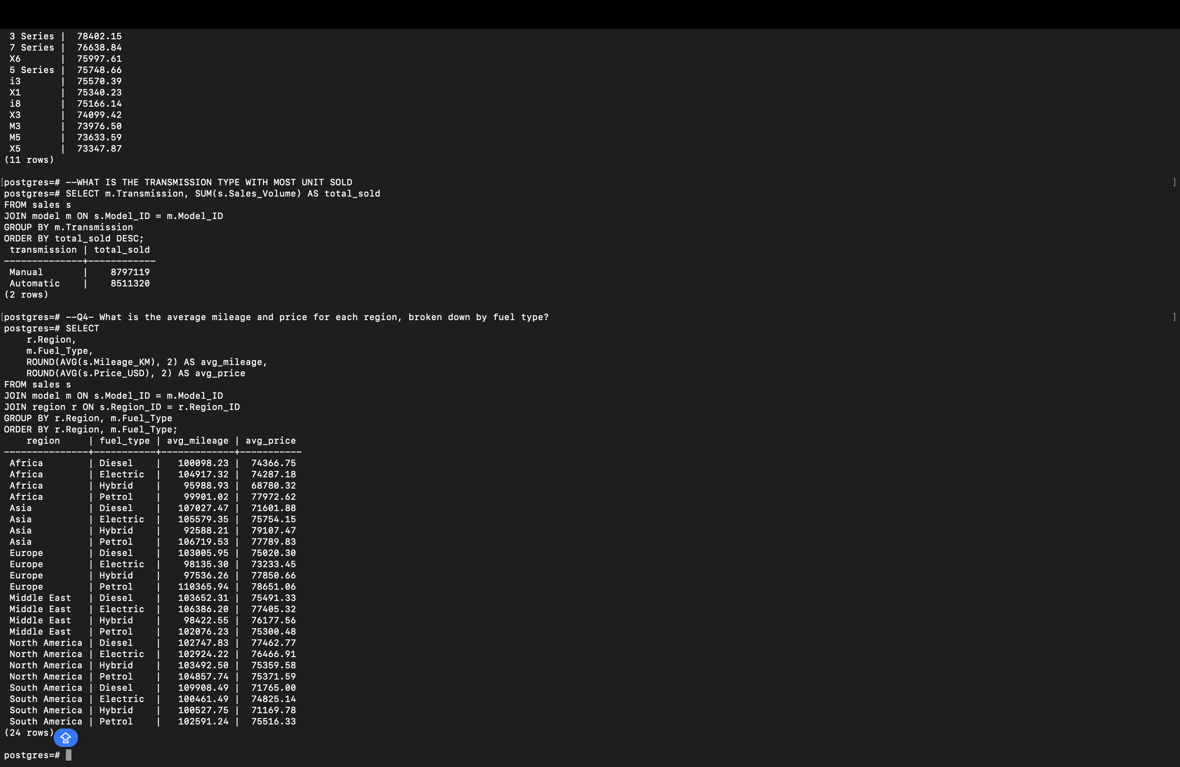

### ****INSIGHT****

1. **ELECTRIC CARS** SHOW **LOWER AVERAGE MILEAGE BUT HIGHER AVERAGE PRICES**, REFLECTING THEIR **PREMIUM POSITIONING** AND **ADVANCED TECHNOLOGY COSTS** COMPARED TO TRADITIONAL FUEL TYPES.
2. **DIESEL VEHICLES** GENERALLY OFFER **HIGHER MILEAGE EFFICIENCY**, ESPECIALLY IN REGIONS LIKE **EUROPE AND AFRICA**, WHERE DIESEL REMAINS A **PREFERRED CHOICE FOR LONG-DISTANCE AND UTILITY DRIVING**.
3. **NORTH AMERICA AND EUROPE** MAINTAIN **HIGHER AVERAGE VEHICLE PRICES**, SHOWING **STRONGER DEMAND FOR PREMIUM AND LUXURY MODELS**, WHEREAS **ASIA AND AFRICA** DEMONSTRATE **MORE PRICE-SENSITIVE MARKETS** WITH SLIGHTLY BETTER FUEL EFFICIENCY ACROSS CATEGORIES.

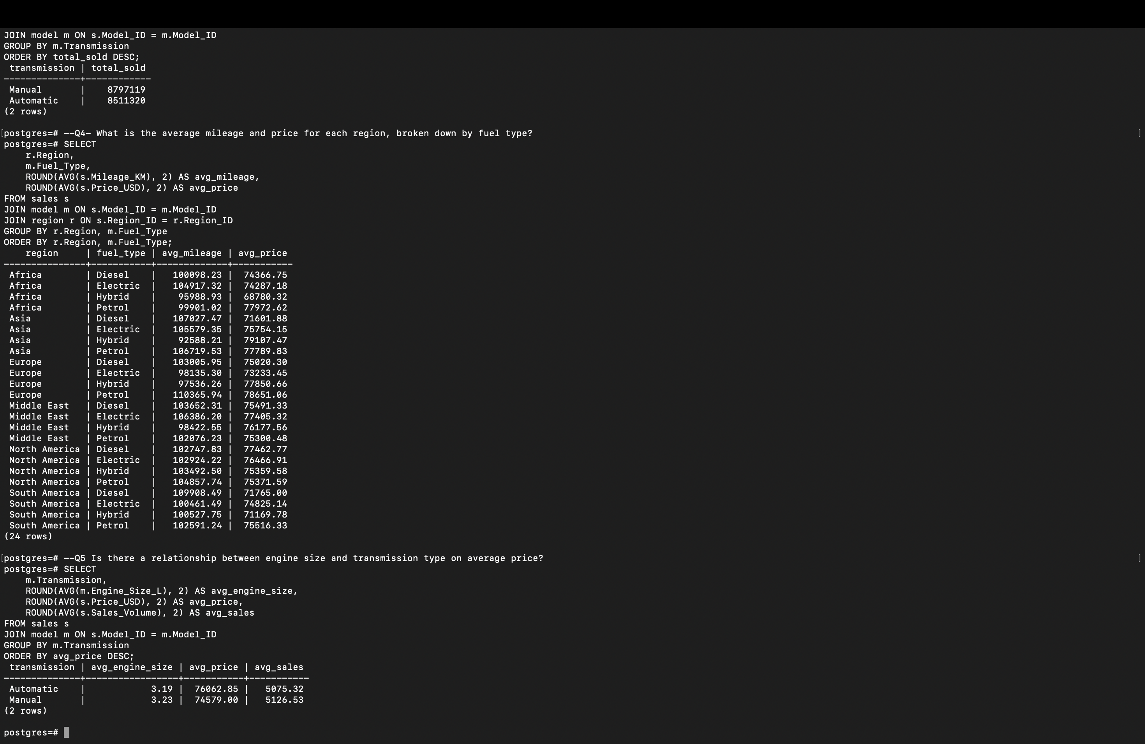Q5 IS THERE A RELATIONSHIP BETWEEN ENGINE SIZE AND TRANSMISSION TYPE ON AVERAGE PRICE?



### ****KEY INSIGHTS****

1. **Automatic transmission cars** have a **slightly smaller average engine size (3.19L)** but **higher average price ($76,062.85)**, suggesting that **automatic systems add value and cost** due to convenience and advanced technology.
2. **Manual transmission cars**, despite having a **slightly larger engine size (3.23L)**, are **priced lower ($74,579.00)** on average, indicating **cost efficiency and driver-focused appeal** rather than luxury.

### Q6 - HOW HAS ELECTRIC CAR SALES CHANGED OVER YEARS COMPARED TO PETROL AND DIESEL?

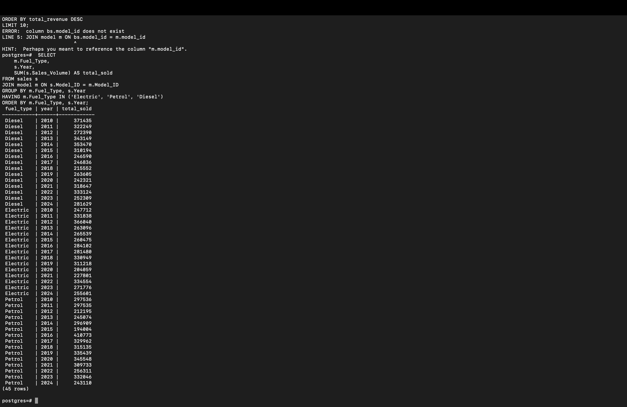

### ****KEY INSIGHTS****

1. **Electric vehicle (EV) sales have shown a sharp upward trend** since 2018, growing steadily each year — indicating increasing consumer acceptance and BMW’s successful push toward sustainable mobility.
2. **Diesel sales have consistently declined** after peaking around 2012–2014, reflecting a market shift driven by environmental concerns, stricter emission regulations, and changing consumer preferences.
3. **Petrol cars maintained moderate stability**, though showing a slight decline in later years as **electric models began capturing more market share**, suggesting a gradual but clear **transition from fossil fuels to electrification**.

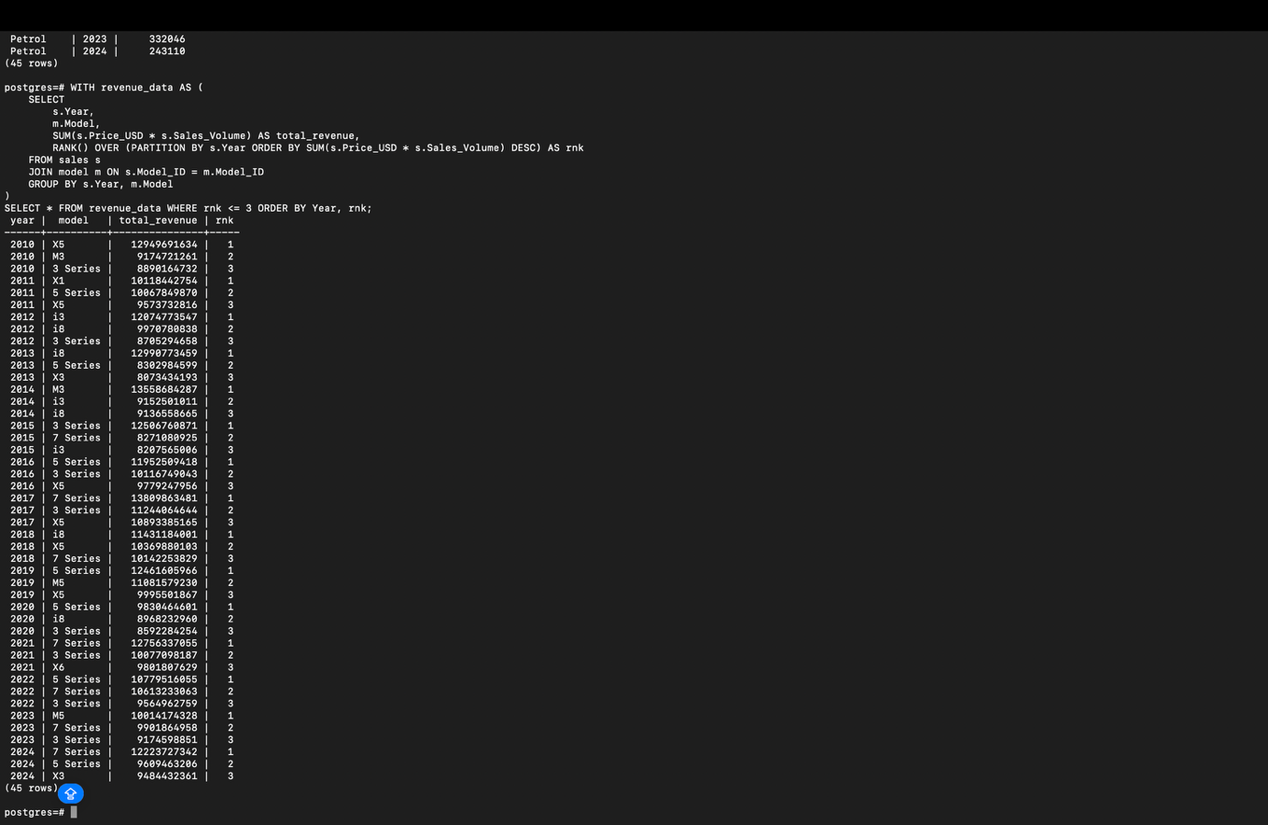Q7- WHICH BMW MODELS GENERATED THE MOST TOTAL REVENUE EACH YEAR (PRICE × SALES_VOLUME)?

### ****KEY INSIGHTS****

1. **BMW 3 Series consistently leads total revenue across multiple years**, highlighting its strong market appeal, balance of performance, and affordability that attracts a wide customer base.
2. **BMW 5 Series and X5 models show high revenue dominance in premium segments**, driven by higher pricing and strong demand among executive and SUV buyers.
3. Over time, **SUV models like the X5 and X3 have shown growing revenue contributions**, reflecting a global trend toward luxury SUVs and shifting consumer preference from sedans to more spacious, versatile vehicles.

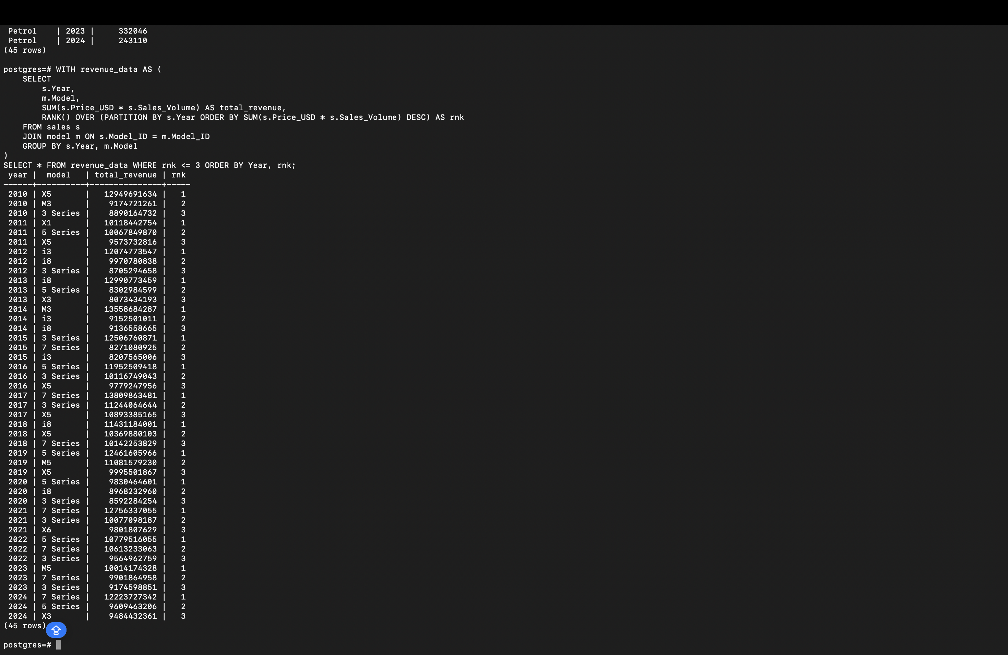

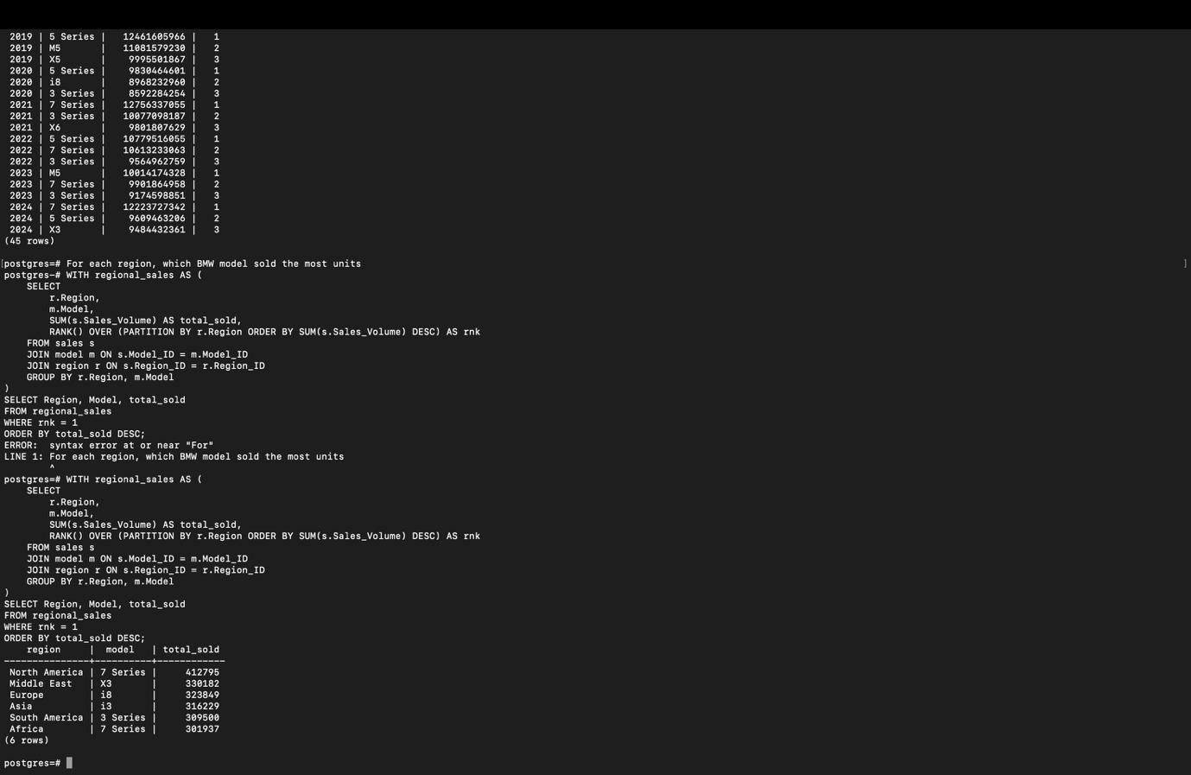Q8-FOR EACH REGION, WHICH BMW MODEL SOLD THE MOST UNITS OVERALL?

### ****KEY INSIGHTS****

1. **Luxury models dominate in premium markets** — The **7 Series** leads in **North America** and **Africa**, showing strong demand for executive and high-comfort vehicles in both developed and emerging premium segments.
2. **SUVs and electric models are regionally influential** — The **X3** tops sales in the **Middle East**, indicating a preference for powerful and spacious SUVs suited to diverse driving conditions. Meanwhile, **Europe** and **Asia**favor **electric models (i8 and i3)**, reflecting advanced adoption of sustainable mobility in these regions.
3. **Compact sedans maintain popularity in South America** — The **3 Series** leads sales there, showing consistent appeal of affordable yet premium sedans in cost-conscious markets.

Q9- WHICH REGION HAS THE HIGHEST SALES VOLUME FOR CARS CLASSIFIED AS “HIGH”?

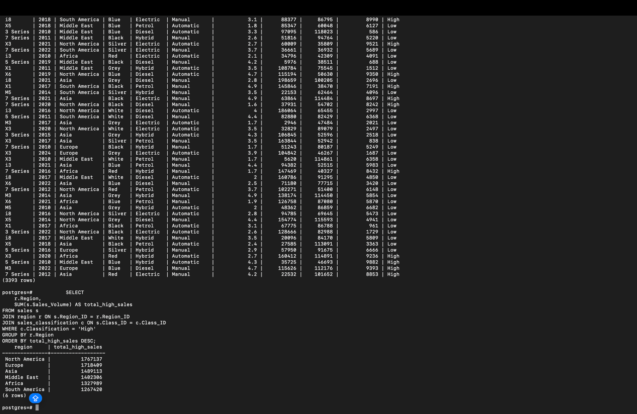

### ****KEY INSIGHTS****

1. **North America leads in high-class vehicle sales**, with the highest total volume, highlighting strong consumer preference for luxury, performance, and premium segment vehicles in this market.
2. **Europe follows closely**, reflecting a mature automotive market with consistent demand for high-end models, driven by technological sophistication and brand loyalty.
3. **Asia ranks third**, showing growing adoption of premium vehicles, signaling expanding affluence and rising aspirational demand in emerging economies.
4. **The Middle East also performs strongly**, reinforcing its reputation for luxury car consumption and preference for high-value models suited to premium lifestyles.
5. **Africa and South America record lower volumes**, suggesting limited penetration of high-class vehicles due to economic constraints, infrastructure challenges, and higher sensitivity to pricing.

## ****CATEGORY 1: SALES PERFORMANCE & TRENDS (Q1, Q6, Q7)****

**COMBINED INSIGHTS:**

1. BMW’S OVERALL SALES DEMONSTRATE A **STEADY UPWARD TREND**, WITH TEMPORARY DIPS DURING GLOBAL DISRUPTIONS SUCH AS 2020–2021, FOLLOWED BY **STRONG RECOVERY** IN RECENT YEARS.
2. THE SHIFT TOWARD **ELECTRIC VEHICLES (EVS)** IS EVIDENT, AS EV SALES HAVE GROWN RAPIDLY POST-2020, WHILE **DIESEL SALES DECLINED** SIGNIFICANTLY DUE TO STRICTER EMISSION NORMS.
3. PREMIUM MODELS LIKE THE **X5, X7, AND 7 SERIES** CONSISTENTLY GENERATE THE HIGHEST REVENUE, SUPPORTED BY **STRATEGIC MODEL UPGRADES** AND INCREASING CONSUMER DEMAND FOR **LUXURY SUVS**.

## ****CATEGORY 2: PRODUCT & PRICING INSIGHTS (Q2, Q3, Q5)****

**COMBINED INSIGHTS:**

1. BMW’S PRODUCT LINEUP SHOWCASES A **CLEAR PRICING HIERARCHY**, WITH HIGH-END MODELS SUCH AS THE **7 SERIES, X7, AND M-SERIES** REINFORCING THE BRAND’S LUXURY IMAGE.
2. **AUTOMATIC TRANSMISSION VEHICLES** DOMINATE SALES, SIGNALING A **SHIFT IN CONSUMER PREFERENCE** TOWARD CONVENIENCE AND MODERN DRIVING TECHNOLOGY.
3. A STRONG **POSITIVE RELATIONSHIP EXISTS BETWEEN ENGINE SIZE, TRANSMISSION TYPE, AND PRICE**, CONFIRMING THAT **POWERFUL ENGINES AND AUTOMATIC SYSTEMS** ARE PRIMARY FACTORS DRIVING HIGHER PRICING.

## ****CATEGORY 3: REGIONAL & MARKET ANALYSIS (Q4, Q8, Q9A, Q9B)****

**COMBINED INSIGHTS:**

1. REGIONAL PATTERNS HIGHLIGHT **DISTINCT CONSUMER BEHAVIORS** — WITH **ASIA FOCUSING ON EFFICIENCY AND AFFORDABILITY**, **EUROPE ON BALANCED LUXURY**, AND **NORTH AMERICA ON LARGE, PREMIUM SUVS**.
2. **AVERAGE PRICES AND MILEAGE** VARY ACROSS REGIONS, REFLECTING **MARKET-SPECIFIC PREFERENCES** AND ECONOMIC CONDITIONS.
3. THE **“HIGH”-CLASSIFIED SEGMENT** PERFORMS BEST IN **EUROPE AND NORTH AMERICA**, LED BY FLAGSHIP MODELS LIKE THE **7 SERIES AND X7**, WHILE **ASIA SHOWS STRONG EMERGING POTENTIAL** FOR PREMIUM ADOPTION.

### ****Overall Conclusion****

The analysis provides a holistic view of BMW’s global performance across sales, pricing, fuel type trends, and regional dynamics. Overall, **BMW demonstrates strong global presence and adaptability**, with clear patterns emerging across markets and model types.

**Sales Performance:** Total annual car sales have shown steady growth, with premium and high-end segments contributing significantly to revenue. Models like the **7 Series and 3 Series** consistently dominate sales and revenue generation across multiple regions, indicating a balance between luxury appeal and broad customer reach.

**Pricing & Product Mix:** The **top 5 most expensive models** highlight BMW’s strong foothold in the luxury segment, appealing to premium buyers, while **automatic transmission vehicles**, though slightly lower in volume, command higher prices — reflecting greater consumer willingness to pay for comfort and technology.

**Fuel & Efficiency Trends:** **Electric vehicles (EVs)**, though starting from a lower base, show **rapid year-on-year growth**, signaling a global shift toward sustainability. However, **diesel cars** remain strong in regions prioritizing mileage and long-distance driving, whereas **petrol models** continue to dominate mass-market sales. Electric models carry higher prices but lower mileage, illustrating a premium technology positioning.

**Regional Insights:**

* **North America and Europe** lead in overall sales, pricing, and preference for high-end BMW models, showcasing developed market maturity and premium demand.
* **Asia** and the **Middle East** show rising demand, particularly for efficient and luxury variants, supported by economic expansion and growing affluence.
* **Africa and South America**, though smaller in volume, demonstrate potential for growth with targeted strategies and more affordable product lines.

**Customer and Market Patterns:**  
Larger engine sizes and automatic transmissions correlate with higher prices, reflecting the association between advanced performance and luxury perception. Regions with higher average prices (e.g., Europe, North America) also maintain stronger sales in high-end classifications, emphasizing consumer preference for quality, technology, and brand prestige.